2 structural steel plates (K = 60.5 W/mK)

each of length 100mm, breadth 30mm, thickness 10mm, contact with 100mm \* 10mm face.

Weld (heat source) line along the 100mm edge

Radiation Emissivity 1, Ambient Temperature 25 deg C.

Convection Film Coefficient 100 W/m^2 C Ambient Temperature 25 deg C.

Moving Heat source

Beam radius 1.5 mm

Power density 10^8 W/m^2

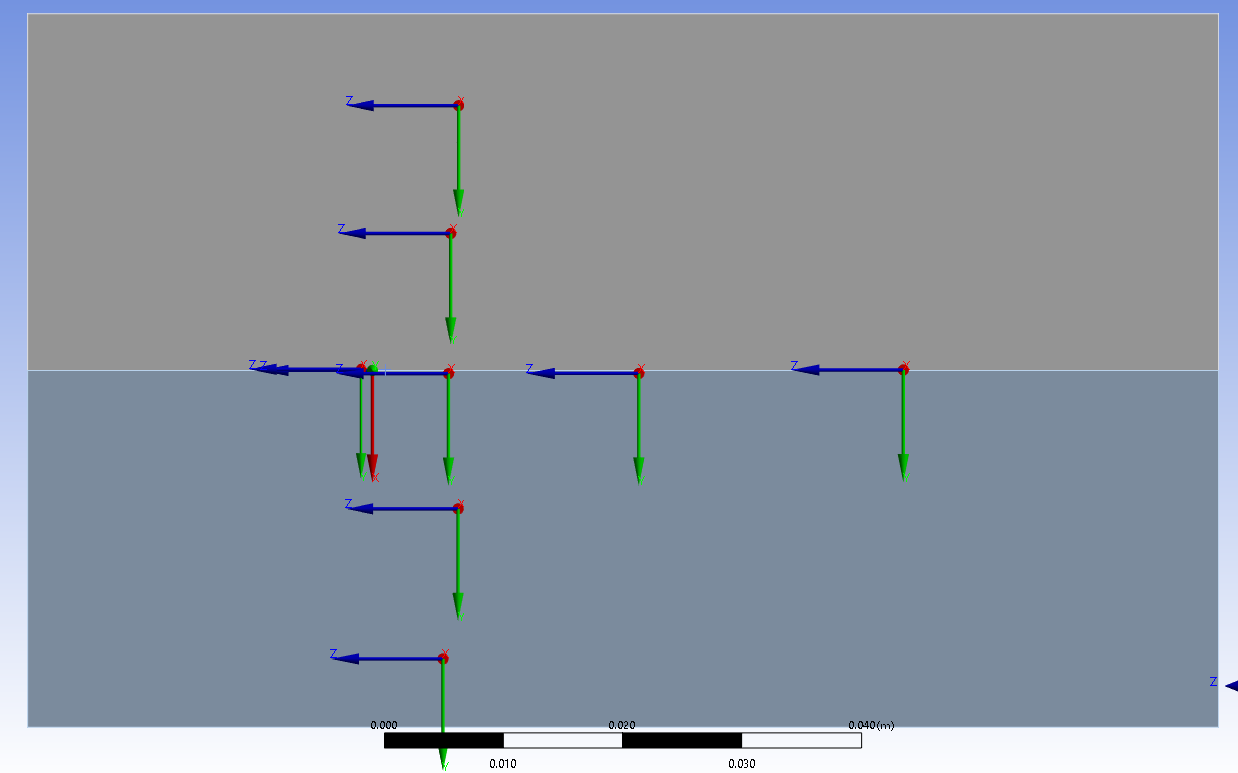

Velocity of source 0.5mm/s

Velocity of Source 5mm/s

